Project Report

1. Title Page
- AI-Based Nuclear Power Plant Monitoring and Inspection Robot System
- Student Names:
Bonthu Vaasita – AV.SC.U4AIE24008
Kandikatla Nikshitha – AV.SC.U4AIE24024
Sivaramannagari Khyathisree – AV.SC.U4AIE24052
- Name of the university : Amrita Vishwa Vidyapeetham
- Date of submission : 22-03-2026
2. Abstract
Nuclear power plants are complex and high-risk environments where continuous monitoring is essential for safe operation. These environments expose workers to hazards such as radiation, toxic gas leaks, and extreme temperatures. Traditional inspection methods rely heavily on human involvement, which increases the risk of accidents and health issues. Therefore, there is a strong need for automated systems that can perform inspection and monitoring tasks without direct human presence.
Existing monitoring systems in nuclear plants often lack full automation and real-time coordinated response to hazardous situations. While some systems use sensors or individual robots, they do not effectively integrate autonomous robots and drones for continuous monitoring and emergency handling. Additionally, many existing approaches do not provide dynamic simulation and visualization of hazard scenarios, limiting their effectiveness in testing and analysis.

The main objective of this project is to develop an AI-based nuclear power plant monitoring and inspection system using autonomous robots and drones. The system aims to continuously monitor environmental parameters such as temperature, radiation, gas levels, and pressure. It also focuses on detecting hazardous conditions and initiating an automatic response, thereby reducing human involvement in dangerous environments.

The proposed system uses an inspection robot and a drone to perform real-time monitoring and surveillance of the plant. The robot follows predefined patrol paths across different zones, collects sensor data, and identifies anomalies. In case of a gas leak or dangerous situation, the robot retreats to a safe zone and signals a secondary robot to handle the emergency. A drone provides aerial monitoring and supports communication. The entire system is implemented using a simulation-based approach.

The simulation results demonstrate that the system successfully detects hazardous conditions such as gas leaks and abnormal temperature or radiation levels. It effectively triggers automated responses, including robot retreat and deployment of a secondary robot for hazard control. The system ensures continuous monitoring and improves safety by minimizing human exposure to dangerous conditions

The proposed system is implemented using VPython, a 3D simulation tool that enables visualization of the nuclear plant environment. VPython is used to model the plant infrastructure, robot movement, drone operations, hazard detection, and response mechanisms. It also provides real-time graphical representation of sensor data and system behavior, making it suitable for demonstrating the effectiveness of the proposed approach.
3. Introduction
Nuclear power plants require constant monitoring to ensure safety and efficiency. Manual inspection in such environments is risky due to radiation exposure, toxic gas leaks, and high temperatures. This project develops a robotic inspection system that automates monitoring and hazard detection using robots and drones.
To safely navigate through the nuclear plant environments , detect radiation and water contamination levels and recommended appropriate purification actions and changes without any human intervention.
The objective of a nuclear plant inspection robot is to inspect, monitor, and assess the condition of nuclear facilities while minimizing human exposure to radiation and hazardous environments. Human entry is restricted near the nuclear plant to ensure the safety , the robot detects the environment changes and suggest appropriate mitigations.
Thus, this improves safety in nuclear plants, Reduces human risk, Enables real-time monitoring and supports industrial automation.
This study focuses on developing an AI-based nuclear power plant inspection system using robots and drones. It addresses key questions such as how effectively the system can monitor environmental parameters like temperature, radiation, gas levels, and pressure, and whether it can detect hazardous conditions in real time. It also examines the efficiency of a multi-robot system in handling emergency situations without human intervention, as well as the role of drone-based monitoring in improving surveillance and communication. The study is based on the hypothesis that the proposed system can successfully detect hazards and initiate automated responses, thereby reducing human exposure to dangerous environments. It is also assumed that real-time monitoring and simulation using VPython enhance system performance, safety, and reliability.
4. Literature Review
Several studies have been conducted on robotic inspection systems and automated monitoring in hazardous environments such as nuclear power plants. Research papers highlight the use of mobile robots for inspection tasks, which can navigate industrial environments and collect data using sensors. Additionally, drone-based monitoring systems have been widely explored for aerial surveillance, providing real-time visual feedback and improving coverage in large facilities. IoT-based monitoring systems are also commonly used to track parameters like temperature, gas concentration, and radiation levels. These studies demonstrate that automation can significantly enhance safety and efficiency in industrial environments.

However, from the existing literature, it is observed that most systems focus on either individual robots or sensor-based monitoring, without integrating multiple agents such as inspection robots, responder robots, and drones into a unified system. Many approaches also lack real-time coordinated response mechanisms for handling emergencies like gas leaks or radiation spikes. Furthermore, limited work has been done on simulation-based visualization that combines environmental monitoring, robotic movement, and hazard response in a single platform.

The motivation for this project arises from the need to develop a safer and more efficient inspection system that minimizes human involvement in dangerous nuclear plant environments. The project aims to overcome the limitations of existing systems by introducing a coordinated, multi-agent approach capable of real-time monitoring and automated response.

The main contribution of this work is the design and implementation of an AI-based inspection system that integrates an autonomous inspection robot, a shielded responder robot, and a drone for continuous monitoring and emergency handling. The system provides real-time data analysis, hazard detection, and automated decision-making, along with a visual simulation of plant operations.

The proposed approach differs from existing methods by combining multiple technologies into a single system, including multi-robot coordination, drone-assisted monitoring, real-time sensor simulation, and automated hazard response. Unlike traditional systems, this model demonstrates a complete workflow from detection to response using a 3D simulation environment, thereby improving system reliability, safety, and effectiveness.
5. Methodology
The proposed system consists of an autonomous inspection robot (Robot 1), a shielded responder robot (Robot 2), and an aerial drone. The inspection robot performs continuous patrol across different zones of the nuclear plant, including the reactor, turbine, pump, and cooling areas. It collects real-time data such as temperature, radiation, gas levels, and pressure. When abnormal conditions such as gas leakage or high radiation are detected, the robot sends alerts and retreats to a safe zone. A secondary shielded robot is then deployed to handle the hazardous situation by performing suppression operations. The drone provides aerial monitoring, enhances communication, and supports real-time data visualization. The entire system is simulated using VPython, where all components interact dynamically within a 3D environment.
Algorithm:
- Initialize the nuclear plant environment and robotic system
- Start Robot 1 patrol across predefined zones
- Continuously collect sensor data (temperature, gas, radiation, pressure)
- Compare sensor values with threshold limits
- If values are within safe limits → continue patrol
- If abnormal condition detected → trigger alert
- Robot 1 retreats to a safe zone
- Activate Robot 2 for emergency response
- Robot 2 performs gas suppression or hazard control
- Drone monitors the situation and updates data
- Once conditions are safe → resume normal patrol
The algorithm initializes the system and starts the inspection robot patrol. It continuously monitors parameters like temperature, gas, and radiation, and compares them with safety limits. If a hazard is detected, the robot retreats to a safe zone, an alert is triggered, and a responder robot handles the situation while the drone monitors. Once conditions return to normal, the system resumes regular operation.

Pseudocode:
Start
Initialize system
While system is running:
Read sensor values
If (gas > threshold OR radiation > limit OR temperature > limit):
Trigger alert
Robot1 → move to safe zone
Activate Robot2
Robot2 → perform suppression
Else:
Robot1 continues patrol
Drone monitors and updates data
End

Flowchart:
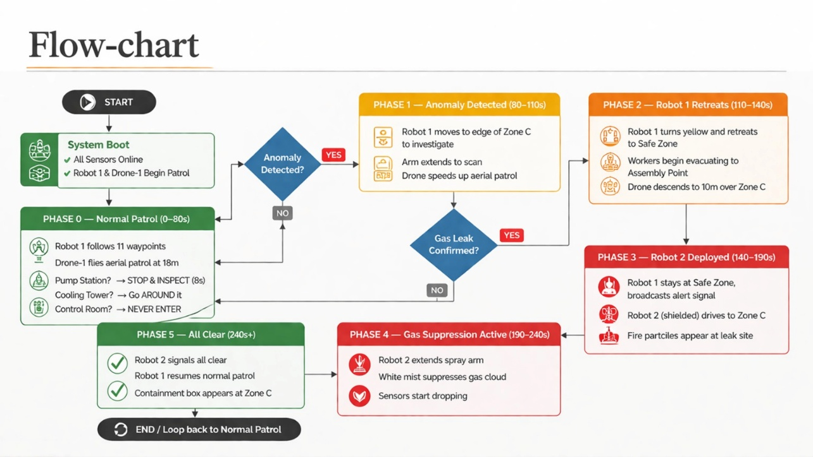
Explanation:
The system is analyzed using simulation-based techniques, where the behaviour of robots, drones, and environmental parameters is observed in real time. Graphical outputs such as temperature, radiation, gas levels, and battery performance are plotted to evaluate system efficiency. The analysis also includes monitoring response time, accuracy of hazard detection, and effectiveness of automated actions. This approach helps validate the reliability and performance of the proposed system under different scenarios.

Research Design:
The research design used in this project is a mixed approach, combining both qualitative and quantitative methods. Quantitative analysis is performed through numerical sensor data such as temperature, gas levels, and radiation values. Qualitative analysis is achieved through visual simulation, system behavior observation, and performance evaluation of robotic operations.
Methodology analysis techniques:
The system is analyzed using simulation-based techniques, where the behavior of robots, drones, and environmental parameters is observed in real time. Graphical outputs such as temperature, radiation, gas levels, and battery performance are plotted to evaluate system efficiency. The analysis also includes monitoring response time, accuracy of hazard detection, and effectiveness of automated actions. This approach helps validate the reliability and performance of the proposed system under different scenarios.
6. Results and Discussion
The project was implemented using Python and VPython, which enabled 3D visualization of the nuclear plant environment along with robot and drone operations. The simulation produced real-time outputs showing robot movement, hazard detection, and automated response actions. The findings are presented using graphical plots such as temperature, radiation, gas levels, and battery status over time, which clearly indicate system behavior under normal and emergency conditions.
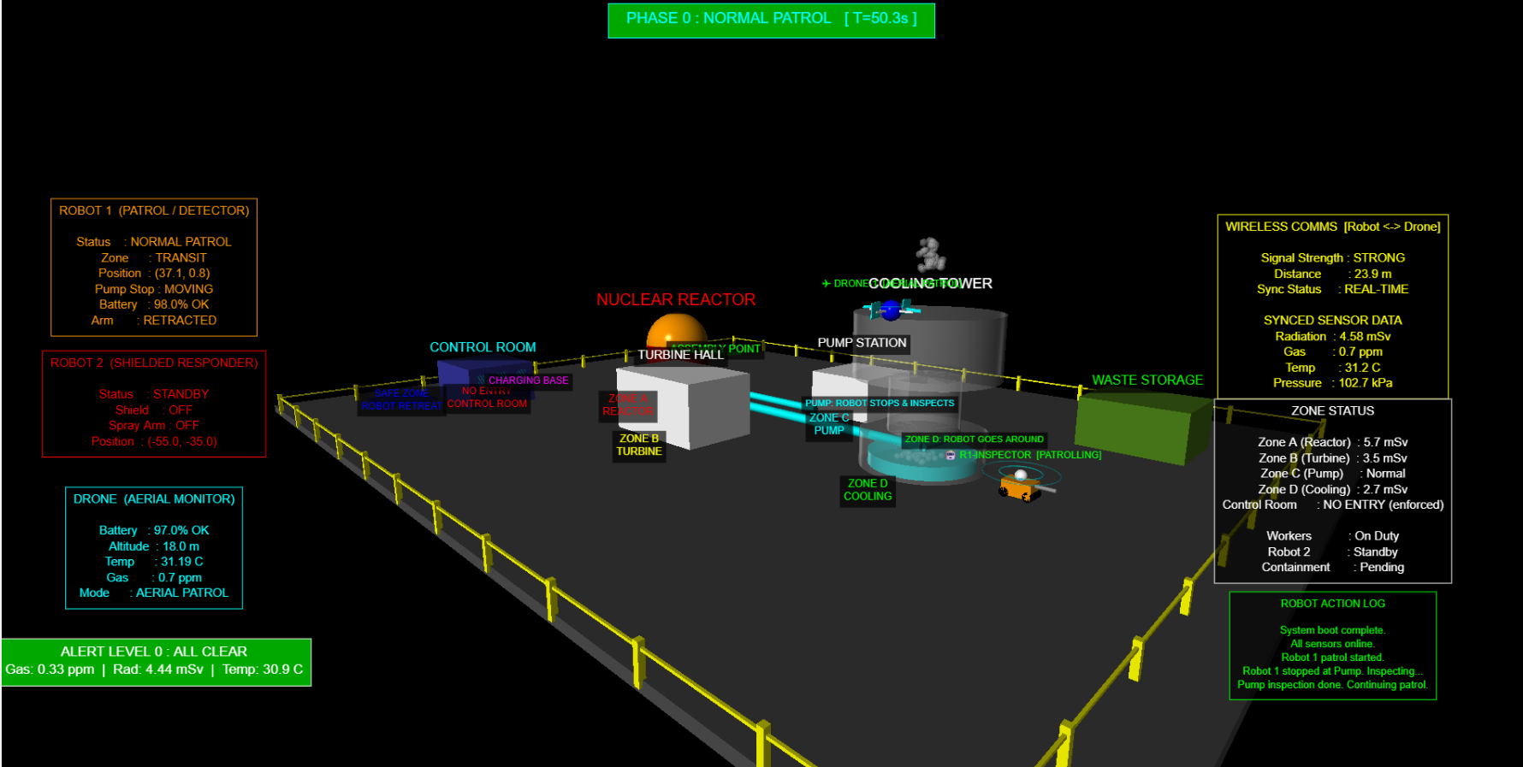
Basic statistical analysis was performed by observing variations in sensor values and identifying threshold crossings that trigger alerts. The graphs show a gradual increase in gas levels and temperature during hazardous conditions, followed by a decrease after the responder robot performs suppression. The results confirm that the system accurately detects anomalies and responds efficiently. Overall, the simulation demonstrates reliable performance in monitoring, hazard detection, and automated control, validating the effectiveness of the proposed system.
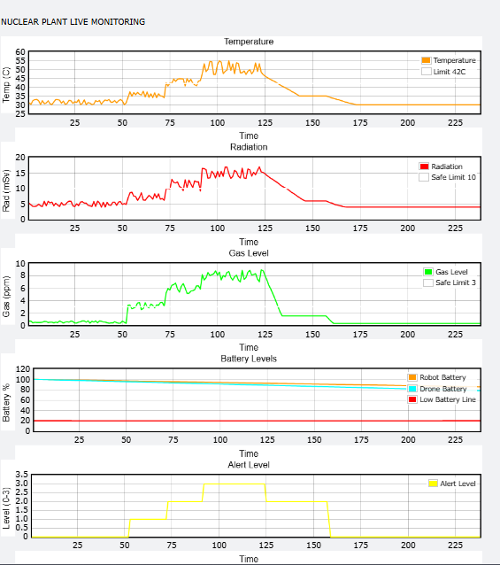
The graphs represent the real-time monitoring of key environmental parameters in the nuclear plant. The temperature graph shows that the values remain within a safe range and do not exceed the threshold limit of 42°C, indicating stable conditions. The radiation graph fluctuates slightly but stays below the safe limit of 10 mSv, showing no critical radiation exposure. The gas level graph remains below the safe limit of 3 ppm during normal operation, but it can increase during hazardous conditions, which helps trigger alerts in the system. The battery level graph shows a gradual decrease in both robot and drone battery levels over time, indicating continuous operation and energy consumption, and The alert graph shows how the system reacts in real time as conditions change from normal to emergency.
Overall, the graphs demonstrate that the system effectively monitors environmental conditions, detects abnormal changes, and maintains safe operational limits while tracking system performance.

7. Conclusion and Recommendations
The project successfully demonstrates an AI-based nuclear power plant monitoring and inspection system using robots and drones. The key findings show that the system can effectively monitor environmental parameters such as temperature, radiation, and gas levels, detect hazardous conditions in real time, and initiate automated responses like robot retreat and emergency handling. This improves safety and reduces the need for human intervention in dangerous environments.
The practical contribution of this work is the development of a smart inspection system that integrates robots, drones, and real-time monitoring for industrial safety. Theoretically, it provides a model for multi-agent systems and automated hazard detection in high-risk environments.
However, the system has some limitations as it is based on simulation and uses randomly generated sensor data instead of real hardware inputs. Future research can focus on implementing the system with real sensors and physical robots, integrating machine learning for predictive analysis, and using advanced platforms like ROS or Gazebo for more realistic simulations.

8. References
[1] L. Briones, P. Bustamante, and M. A. Serna, “Wall-climbing robot for inspection in nuclear power plants,” Robotics and Autonomous Systems, vol. 14, no. 2–3, pp. 141–150, 1995.
[2] P. Cao, E. K. Houck, A. D’Andrea, et al., “Development of a multi-robot system for autonomous inspection of nuclear waste tank pits,” Applied Sciences, vol. 15, no. 3, pp. 1–15, 2025.
[3] H. Yamamoto, “Development of inspection robot for nuclear power plant,” in Proc. IEEE Int. Conf. Robotics and Automation, 2000, pp. 1–5.
[4] S. Puppala, I. Hossain, J. Alam, and S. Talukder, “Optimus-Q: AI-based adaptive robot for nuclear power plant monitoring,” arXiv preprint arXiv:2511.15614, 2025.
[5] H. Xie, L. Huang, and W. Wu, “Indoor positioning system for mobile robots in nuclear power plants,” arXiv preprint arXiv:2011.07771, 2020.
[6] J. Kim, T. Ruan, and C. Contreras, “Human-robot collaboration for inspection in nuclear facilities,” arXiv preprint arXiv:2508.11404, 2025.
[7] Mitsubishi Heavy Industries, “MEISTeR robot for Fukushima nuclear plant inspection,” 2012.

